No/F/DC/2017-18
April 13, 2019
Notice
It is notified for the information of research scholars and students of Semister Ist and 3rd that a meeting is scheduled with the Head of Department in Seminar Hall on April 24,2019 at 11 O’clock .

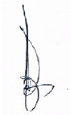
Professor Pirzada M Amin
Copy to;
- Registrar, University of Kashmir for information
- Dean,Academic Affairs ,University of Kashmir for information for n/a
- HA/JA for information and n/a
- File.
- Website.

